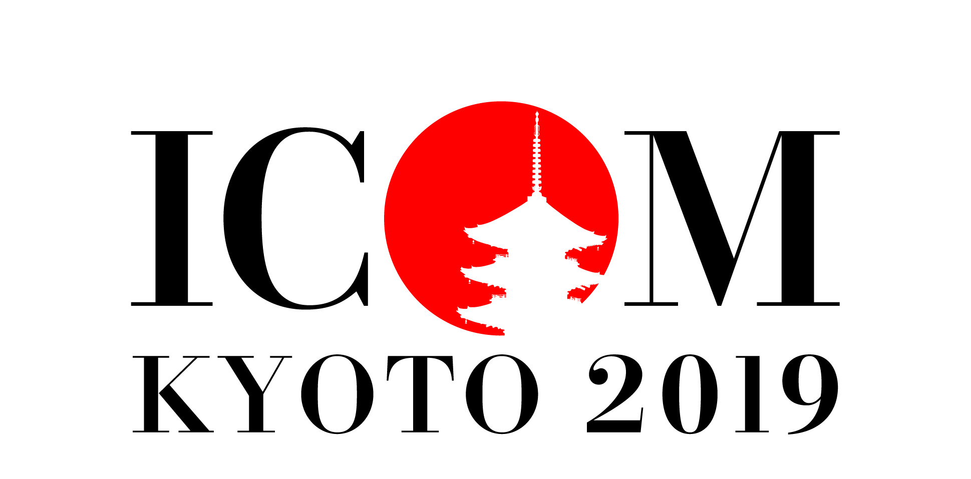

ICOM Maizuru Meeting 2018
Call for Papers
“Cultural Heritage and Museums as Cultural Hubs”
Submission of abstracts: 30 June 2018

Rapid political, economic and social changes have made the role that cultural heritage and museums play in building a better future increasingly important. Each museum is unique, yet it is essential for museums and cultural heritage sites to cooperate in order to demonstrate the value of their existence by constructing networks that engage with local, domestic and international societies. It is only in this way that they may fulfill in its entirely multiple responsibilities in social endeavors.

With the theme “Museums as Cultural Hubs: the Future of Tradition”, ICOM Kyoto 2019 General Conference aims to provide a forum for considering how museums can be hubs to create a richer future whilst respecting the traditions of the past.

At the ICOM Maizuru Meeting, one year before the ICOM Kyoto 2019 General Conference, we would like to welcome research and case studies on this subject, and we hope to pioneer the debate at the ICOM Kyoto 2019 General Conference.

Abstract Requirements and Deadline:
Please send us an abstract of no more than 350 words in English (or 500 characters in Japanese) by filling in the proposal form to
ICOM KYOTO 2019 Office at office@icomkyoto2019.kyoto , before 30 June 2018
with the subject line: “ICOM Maizuru Meeting 2018 paper proposal – [Your Proposed Paper Title]”.

The abstracts of the conference presentations should be delivered in English or Japanese.

Important dates:
Deadline for submission of abstracts: 30 June 2018
Announcement of approved proposals: 31 July 2018
Presentation: 30 September 2018

Preliminary Programme:
September 30 2018 in Maizuru, Japan

ICOM Maizuru Meeting 2018 will be a conference open to the public, with participation of ICOM General Secretariat representatives and ICOM International Committees chairs.

Each presentation will be 10-15 minutes, delivered in English or Japanese. Simultaneous translation will be provided.

For further information or to submit your proposal contact: office@icomkyoto2019.kyoto
ICOM Maizuru Meeting 2018:
Cultural Heritage and Museumsas Cultural Hubs

Proposal form

※ Call for paper related to the themes as below:
THEME 1 – "Global Issues and Museums"
How are museums connecting with the world? What efforts are museums making when it comes to tackling common global issues like disasters and conflicts, environmental issues, internationalisation and globalisation, aging populations, social and economic disparity? This theme could address the methods and mechanisms necessary to solve problems, such as cooperation between countries and regions and forming networks with relevant organisations.
THEME 2 – "Local Communities and Museums”.
How are museums connecting with their communities? How do museums care for and pass on the cultures and cultural properties that have been cultivated in their cities and communities? What are case studies and new models of museums that “connect and inherit cultures” in cooperation with various local stakeholders?

Your Name
Job title / role | /
Organisation
ICOM Member No. (if applicable)
Email
Please tick the theme that your proposal best fits with ※ | □ 1) Global Issues and Museums  □ 2) Local Communities and Museum
Title of the paper
Key words (up to five)
Abstract (350 words max in English or 500 characters in Japanese)

Biography (75 words max or 100 characters in Japanese)

Please submit your completed proposal form to the ICOM KYOTO 2019 Office at office@icomkyoto2019.kyoto by 30 June 2018, with the subject line:
“ICOM Maizuru Meeting 2018 paper proposal – [Your Proposed Paper Title]”.

